ASSIGNMENT-1

SECTION -00

1.Create a directory ‘project_dir’ & cd to ‘project_dir’.

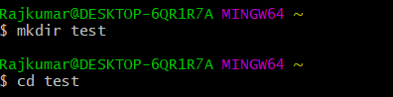

2.Initialize git version database. (git init)

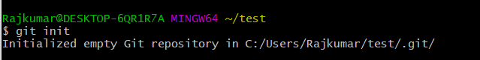

3.Create a new file index.html.

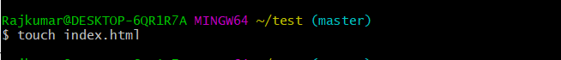

4. Check the git status. You should find index.html as untracked file

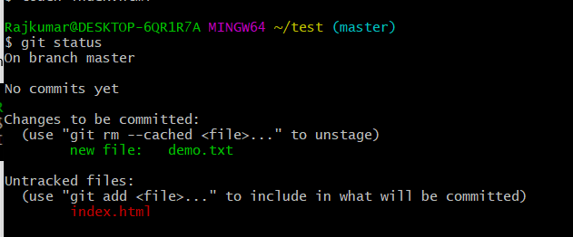

5.Stage the index.html file.

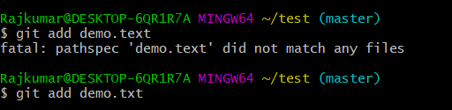

6.Commit index.html

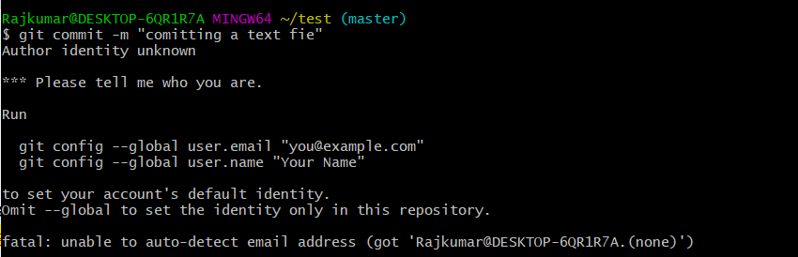

7.Make few changes in index.html & create a new file info.txt file.



8.Check git status. You should find index.html & info.txt as untracked files.

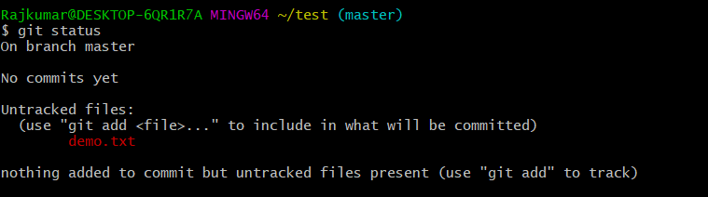

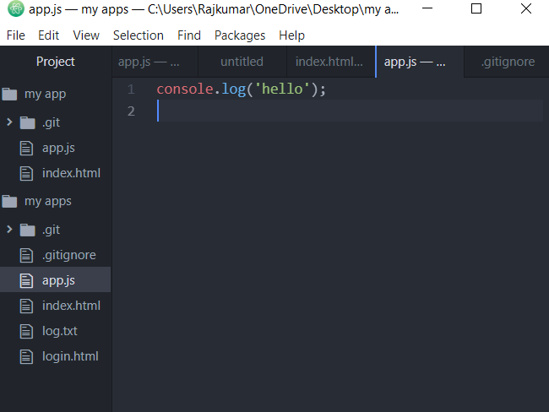

9.Configure GIT to ignore all txt files.

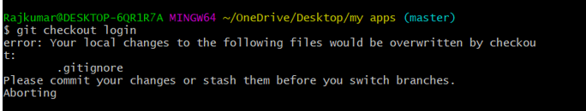

10.Again check the git status. You should find only index.html as untracked file.

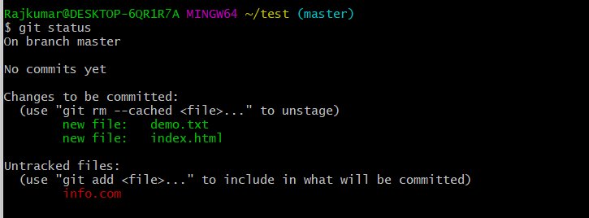

11.State & commit index.html

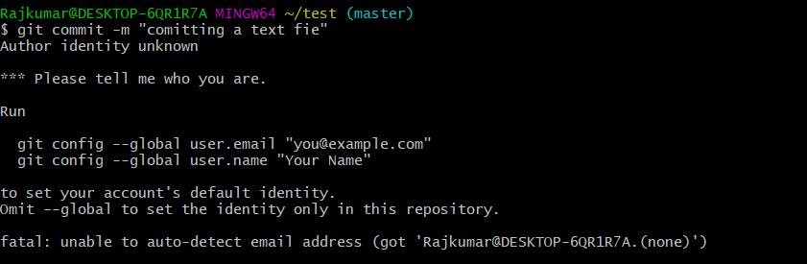

12.Log all your comments so far.

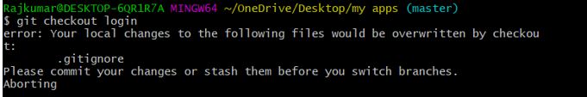

13.Make some changes in index.html.



14.Revert the change made in the previous step using git command.

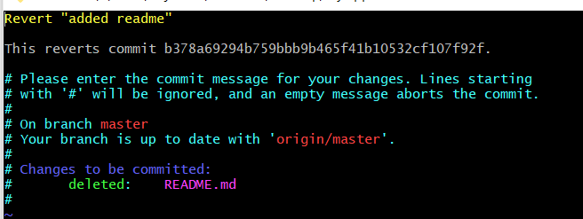

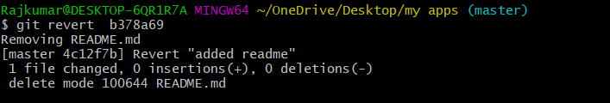

15.Again change index.html.

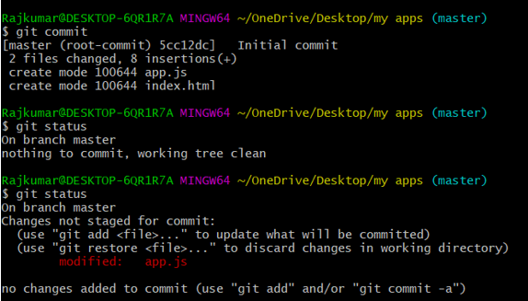

16.Stage index.html



17.Revert back the last stage

18.Rename ‘add’ command to ‘my-add’.



19.Using my_add command Stage index.html again & commit the changes.

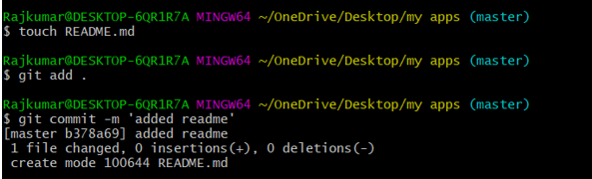

20.Revert the last commit.

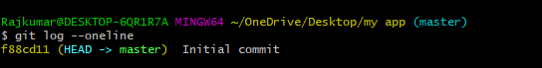

1.First take a backup of your assignments & projects. This is required because due to incorrect GIT operation you may lose your files.



2.Create an empty directory ‘Assignments’ & cd to ‘Assignments’.



3.a file README.txt inside ‘Assignments’ & write few lines about the contents of ‘Assignments’ folder.

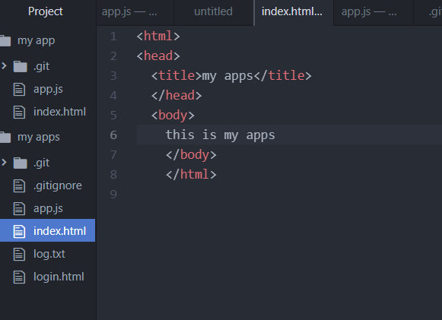

24Commit README.txt file.

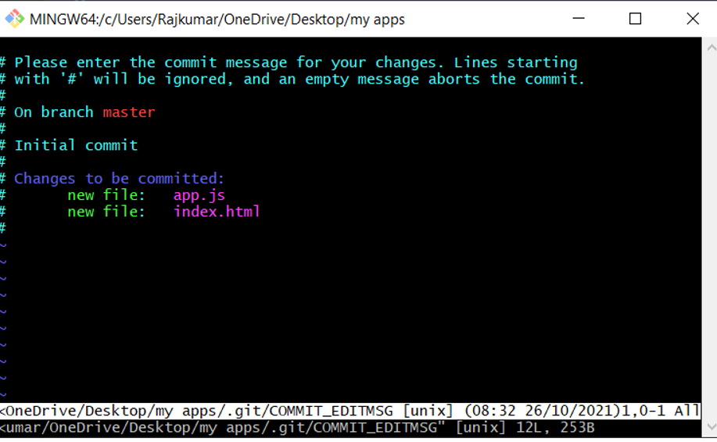

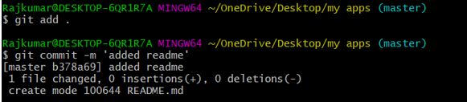

25.Now create a new branch ‘html-assignments’.

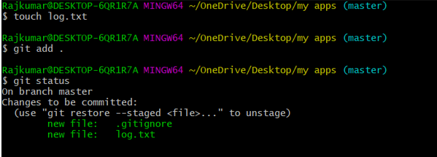

26.

Rajkumar@DESKTOP-6QR1R7A MINGW64 ~/assignment

$ git checkout html-assignments

Switched to branch 'html-assignments'

28,29,30.

Rajkumar@DESKTOP-6QR1R7A MINGW64 ~/assignment

$ git add .

Rajkumar@DESKTOP-6QR1R7A MINGW64 ~/assignment

$ git commit -m "modified html"

[html-assignments 0096afe] modified html

1 file changed, 9 insertions(+)

create mode 100644 Anime.html

31.

Rajkumar@DESKTOP-6QR1R7A MINGW64 ~/assignment

$ git checkout master

Switched to branch 'master'

32.

Rajkumar@DESKTOP-6QR1R7A MINGW64 ~/assignment

$ git add .

Rajkumar@DESKTOP-6QR1R7A MINGW64 ~/assignment

$ git commit -m "modified txt"

[master 1a2a96b] modified txt

1 file changed, 2 insertions(+), 1 deletion(-)

33.

Rajkumar@DESKTOP-6QR1R7A MINGW64 ~/assignment

$ git checkout html-assignments

Switched to branch 'html-assignments'

34,35.

Rajkumar@DESKTOP-6QR1R7A MINGW64 ~/assignment

$ git add .

Rajkumar@DESKTOP-6QR1R7A MINGW64 ~/assignment

$ git commit -m "modified html 2nd time"

[html-assignments 8babf5e] modified html 2nd time

1 file changed, 1 insertion(+)

36.

Rajkumar@DESKTOP-6QR1R7A MINGW64 ~/assignment

$ git checkout master

Switched to branch 'master'

37.

Rajkumar@DESKTOP-6QR1R7A MINGW64 ~/assignment

$ git merge html-assignments

Merge made by the 'recursive' strategy.

Anime.html | 10 ++++++++++

1 file changed, 10 insertions(+)

create mode 100644 Anime.html

38.

Rajkumar@DESKTOP-6QR1R7A MINGW64 ~/assignment

$ git branch -D html-assignments

Deleted branch html-assignments (was 8babf5e).

**SECTION- 02**

1.

Rajkumar@DESKTOP-6QR1R7A MINGW64 ~/assignment

$ git branch css-assignments

2.

$ git checkout css-assignments

Switched to branch 'css-assignments'

M Anime.html

3,4.

Rajkumar@DESKTOP-6QR1R7A MINGW64 ~/assignment

$ git add .

Rajkumar@DESKTOP-6QR1R7A MINGW64 ~/assignment

$ git commit -m "inittial css commit"

[css-assignments 5e7ffb2] inittial css commit

2 files changed, 7 insertions(+), 1 deletion(-)

create mode 100644 anistyle.css

Rajkumar@DESKTOP-6QR1R7A MINGW64 ~/assignment

$ ls

Anime.html README.txt anistyle.css

5,6.

Rajkumar@DESKTOP-6QR1R7A MINGW64 ~/assignment

$ git add .

Rajkumar@DESKTOP-6QR1R7A MINGW64 ~/assignment (css-assignments)

$ git commit -m "change in readme txt file"

[css-assignments 9ad1781] change in readme txt file

1 file changed, 2 insertions(+), 2 deletions(-)

7.

Rajkumar@DESKTOP-6QR1R7A MINGW64 ~/assignment (css-assignments)

$ git checkout master

Switched to branch 'master'

8.

Rajkumar@DESKTOP-6QR1R7A MINGW64 ~/assignment (master)

$ git add .

Rajkumar@DESKTOP-6QR1R7A MINGW64 ~/assignment (master)

$ git commit -m "change in readme txt file in master"

[master 070d854] change in readme txt file in master

1 file changed, 2 insertions(+), 1 deletion(-)

9.

Rajkumar@DESKTOP-6QR1R7A MINGW64 ~/assignment (master)

$ git checkout css-assignments

Switched to branch 'css-assignments'

10,11.

Rajkumar@DESKTOP-6QR1R7A MINGW64 ~/assignment (css-assignments)

$ git add .

Rajkumar@DESKTOP-6QR1R7A MINGW64 ~/assignment (css-assignments)

$ git commit -m "minor css commit"

[css-assignments 935a8cd] minor css commit

1 file changed, 4 insertions(+)

12.

Rajkumar@DESKTOP-6QR1R7A MINGW64 ~/assignment (css-assignments)

$ git checkout master

Switched to branch 'master'

13.

Rajkumar@DESKTOP-6QR1R7A MINGW64 ~/assignment (master|MERGING)

$ git add .

Rajkumar@DESKTOP-6QR1R7A MINGW64 ~/assignment (master|MERGING)

$ git commit -m "commit manually resolve merge"

[master 15f0192] commit manually resolve merge

Rajkumar@DESKTOP-6QR1R7A MINGW64 ~/assignment (master)

$ git status

On branch master

nothing to commit, working tree clean

Rajkumar@DESKTOP-6QR1R7A MINGW64 ~/assignment (master)

$ git merge css-assignments

Already up to date.

14.

Rajkumar@DESKTOP-6QR1R7A MINGW64 ~/assignment (master)

$ git branch -D css-assignments

Deleted branch css-assignments (was 935a8cd).

**SECTION-03**

1.

Rajkumar@DESKTOP-6QR1R7A MINGW64 ~/assignment (master)

$ git branch js-assignments

2.

Rajkumar@DESKTOP-6QR1R7A MINGW64 ~/assignment (master)

$ git checkout js-assignments

Switched to branch 'js-assignments'

M Anime.html

3,4.

Rajkumar@DESKTOP-6QR1R7A MINGW64 ~/assignment (js-assignments)

$ git add .

Rajkumar@DESKTOP-6QR1R7A MINGW64 ~/assignment (js-assignments)

$ git commit -m "initial commit in branch"

[js-assignments 231a4dd] initial commit in branch

2 files changed, 3 insertions(+), 2 deletions(-)

create mode 100644 jsFile.txt

5,6.

Rajkumar@DESKTOP-6QR1R7A MINGW64 ~/assignment (js-assignments)

$ git add .

Rajkumar@DESKTOP-6QR1R7A MINGW64 ~/assignment (js-assignments)

$ git commit -m "committed changes in readme of branch"

[js-assignments 5238742] committed changes in readme of branch

1 file changed, 1 insertion(+), 1 deletion(-)

7.

Rajkumar@DESKTOP-6QR1R7A MINGW64 ~/assignment (js-assignments)

$ git checkout master

Switched to branch 'master'

8.

Rajkumar@DESKTOP-6QR1R7A MINGW64 ~/assignment (master)

$ git add .

Rajkumar@DESKTOP-6QR1R7A MINGW64 ~/assignment (master)

$ git commit -m "committed changes in readme of master"

[master 10e7559] committed changes in readme of master

1 file changed, 1 insertion(+), 1 deletion(-)

9.

Rajkumar@DESKTOP-6QR1R7A MINGW64 ~/assignment (master)

$ git checkout js-assignments

Switched to branch 'js-assignments'

10,11.

Rajkumar@DESKTOP-6QR1R7A MINGW64 ~/assignment (js-assignments)

$ git add .

Rajkumar@DESKTOP-6QR1R7A MINGW64 ~/assignment (js-assignments)

$ git commit -m "commit changes in js file of branch"

[js-assignments 588d293] commit changes in js file of branch

1 file changed, 2 insertions(+), 1 deletion(-)

12.

Rajkumar@DESKTOP-6QR1R7A MINGW64 ~/assignment (js-assignments)

$ git checkout master

Switched to branch 'master'

13.

Rajkumar@DESKTOP-6QR1R7A MINGW64 ~/assignment (master)

$ git merge js-assignments

Auto-merging README.txt

CONFLICT (content): Merge conflict in README.txt

Automatic merge failed; fix conflicts and then commit the result.

Rajkumar@DESKTOP-6QR1R7A MINGW64 ~/assignment (master|MERGING)

$ git add .

Rajkumar@DESKTOP-6QR1R7A MINGW64 ~/assignment (master|MERGING)

$ git commit -m "commit manually resolve merge"

[master d74f5cb] commit manually resolve merge

Rajkumar@DESKTOP-6QR1R7A MINGW64 ~/assignment (master)

$ git merge js-assignments

Already up to date.

14.

Rajkumar@DESKTOP-6QR1R7A MINGW64 ~/assignment (master)

$ git branch -D js-assignments

Deleted branch js-assignments (was 635d758).